**Cyber security Importance:**

**Definition of Cybersecurity**

1. Describe the NIST (National institute and standard technology) definition of Cybersecurity

The measure taken to protect governmental and military computer and weapons systems from unauthorized use, alteration, disruption destruction.

1. Describe the CIA (Confidentiality Integrity and availability) triad and its components these three principles are known as CIA triad.

* **Confidentiality**: Confidentiality is synonymous with privacy. Confidentiality measures prevent data from falling into the hands of people who do not have authorization to access said information.
* **Integrity**: In the information technology world, integrity is all about making sure information is accurate and always stays that way.
* **Availability**: Ensuring availability requires routine maintenance and upgrading of hardware, software, and operating system environments.

1. **key Terms**

* **Vulnerability**: A flaw, loophole, oversight, or error that can be exploited to violate system security policy.
* **Threat**: A threat is an event, natural or man-made, able to cause negative impact to an organization.
* **Exploit**: An exploit is a defined way to breach the security of an IT system through a Vulnerability.
* 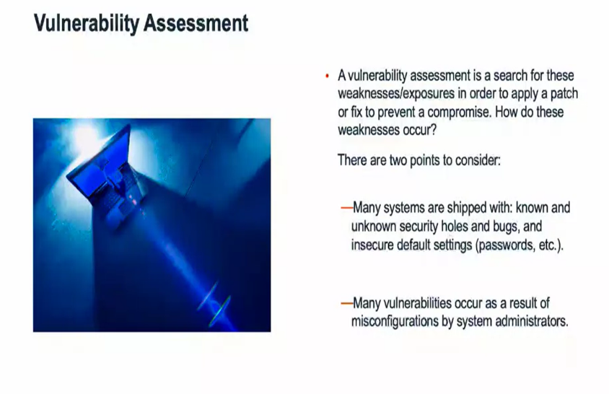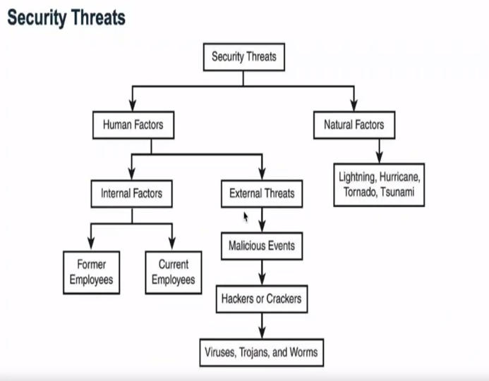**Risk**: It is situation involving exposure to danger.

**Roles in information Security:**

* CISO (Chief Information Security Officer)
* Information Security Architect
* Information Security Consultant/Specialist
* Information Security Analyst
* Information Security Auditor
* Security Software Developer
* Penetration Tester/Ethical Hacker
* Vulnerability Assessor

**Roles**

* CISO (Chief Information Security Officer): Is a high-level management position responsible for the entire computer security department and staff.
* Information Security Architect: This position conducts information security assessments for organizations and analyses the events, alerts, alarms, and any information that could be useful to identify any threats could compromise the organization.
* Information Security Auditor: This position is in change of testing the effectiveness of computer information systems, including the security of the systems and reports their findings.
* Information Security Analyst: Security role would be responsible for conducting information security assessments, including analysing events, alerts, and alarms.

1. What is IT Security?

“Is the protection of computer systems from the theft or damage to the hardware, software or the information on them, as from disruption or misdirection of the services they provide”.